**Pictures:**

You can take screenshots of anything on the computer by hitting: **command + shift + 4**

* You can then use the cursor to drag and select the area you wish to screenshot
* When you release the cursor, the screenshot is automatically saved to the desktop
* Be sure to then rename it and move it to the correct folder

You can also take a screenshot straight from the preview app:

* Open Preview, **Go to File** → **Take Screenshot** → **From Window...**

**Preview instructions:**

**Please duplicate your photo. Preview automatically saves some of your changes, so please always work with a copy of your photograph.**

Simply double clicking on a photograph will open it up in Preview. Preview is our default picture-viewing program.

You will be using Preview to place labels on your photographs.

Text and arrow labels will have to be added to your photographs. Soon after opening your image in preview, save it under a different name and work with this copy. Preview’s big fault is that it saves automatically as your work in it**. Again, no do overs here. So always work with a copy of your original photograph.**

**Add an arrow in Preview**.

Choose annotate from the tool menu and arrow from the sub menu.

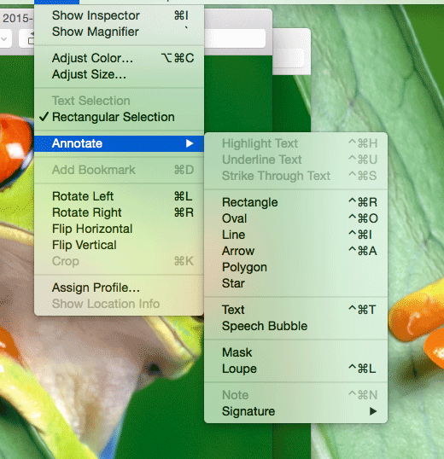

When you click on arrow, you can choose its size.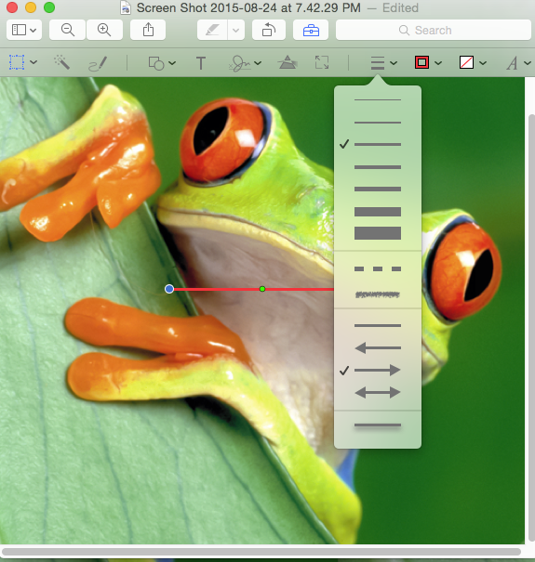

Note its color is red, as noting in the box next to the line size and arrow submenu (black arrow). 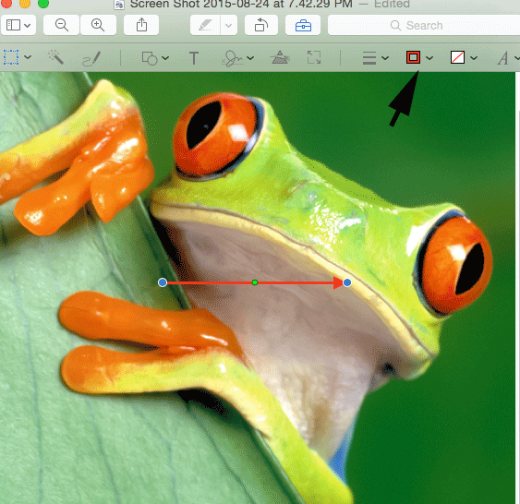

To change its color, click on desire color in color tiles displayed when you mouse over color indicator.

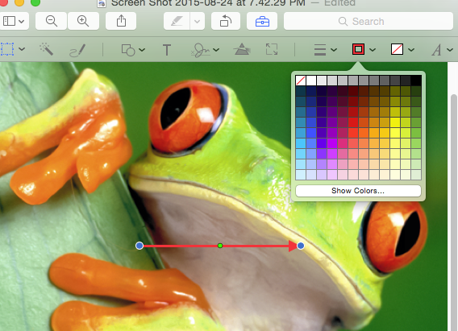

Voila a purple arrow. 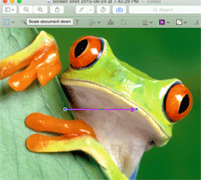

**Add a label.**

Choose text under the annotate menu. A text box appears.

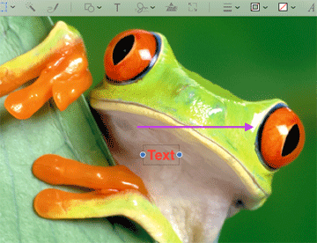

Replace the word text in the box with your own text.

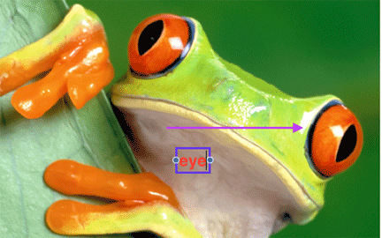

You can change the color of the text or its box or the fill in the box, by simply mouse over the appropriate symbol, open box for initial text box, closed box for fill, letter for text color.

You can move your finished product by selecting it and using the mouse to move it to where you want it.

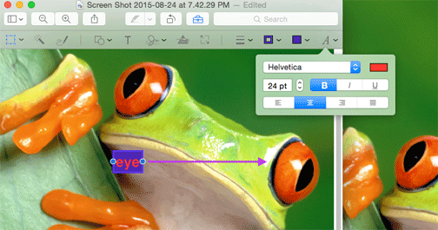

Preview is very powerful. You can resize and crop images, etc. Using scrap images I would take some time to work with it. You will be surprised at how improving contrast in various ways will improve your image.